|  |  |
| --- | --- |
|  | Student Name ______________________________    **Eastern Goldfields College**  Mathematics Applications U1 2019  Test 1 – Calculator Free1 |
|  | Total Marks: 18 marks |

**Time allowed: 15 minutes**

**No calculator or notes permitted for this section.**

***Answer all of the following questions. Show all working where appropriate.***

**Question 1** [6 marks: 1, 1, 2, 2]

Calculate the following percentages:

a) 10% of 222 b) 30% of 50

c) Increase 120 by 75% d) Reduce 90 by 11%

**Question 2** [4 marks: 2, 2]

Consider the following equation, 𝑝=6× $\sqrt{q-9}$ +𝑘

a) Evaluate *p,* if q = 18 and *k* = 25

b) For which values of *q* is this equation NOT valid?

**Question 3** [4 marks: 1, 1, 2]

Consider the following equation, 𝐵 = 10𝐴 − 3𝐶 Evaluate B, if:

1. A = 4 and C = 12
2. A = - 2 and C = 100
3. A = 42 and C =

**Question 4** [4 marks: 1, 1, 2]

Shane uses a spreadsheet to create his weekly budget.

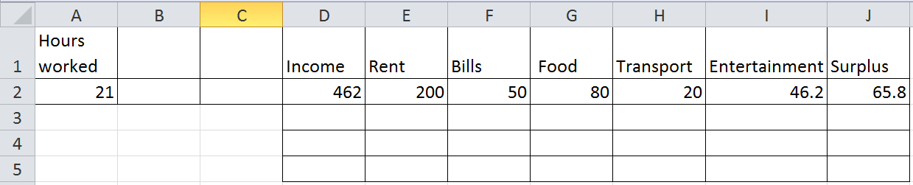

a) Shane earns $22 per hour. If he types the number of hours he works into cell A2, what formula is required in cell D2 so that it calculates his income based on the number of hours he has worked.

b) Shane earns his weekly income and each week he pays $200 in rent. He always sets aside 10% of his pay to spend on entertainment. What formulas are needed to calculate:

i) the amount he sets aside to spend on entertainment.

ii) the amount of surplus he has left at the end of the week.

|  |  |
| --- | --- |
|  | Student Name _______________________    **Eastern Goldfields College**  Mathematics Applications U1 2019  Test 1 – Calculator Assumed1 |
| **Time allowed: 40 minutes** | Total Marks: 38 marks |

**One A4 page of notes IS permitted in this section.**

**Question 1** [7 marks – 2, 2, 3]

An electronics store increased the prices of all laptops by 5%. A laptop originally cost $2290.

1. What was the new price of the laptop after the price increase?

During the end of year sales, all stock was now discounted by 12.5%.

1. What is the price of the laptop during the end of year sales? State your answer to

the nearest 5c.

1. Calculate the overall **percentage change** in price from the original price.

**Question 2** [2 marks]

If GST (10%) was already added onto an account from a plumber and the account came to $185.35, how much was the job before the GST was added on?

**Question 3** [6 marks: 3, 3]

|  |  |  |  |  |  |
| --- | --- | --- | --- | --- | --- |
|  | **A** | **B** | **C** | **D** | **E** |
| **1** | **Unit cost** | **Number ordered** | **Sub total** | **Less 20% discount** | **Plus 10% tax** |
| **2** | $24.10 | 15 | $361.50 | $289.20 | $318.12 |
| **3** | $9.50 | 40 |  | $304 |  |
| **4** | $172.00 |  | $1376.00 |  | $1210.88 |

1. What is the value in cell

1. C3? ii) B4?

Iii) E3? iv) D4?

1. What is the formula in cell

1. C4?
2. D3?
3. E4?

**Question 4** [5 marks: 2, 3]

Skye, Travis and Aisha are planning a holiday to Canada. They have decided to budget and save in order to have enough money for the trip. They each need to save $1500.

1. Aisha was lucky enough to win some money in a competition. Her entire holiday fund of $1500 comes from her prize money. If this is 5% of her total prize money, how much money did she win?
2. Skye is making and selling hair accessories to try and make enough money for the holiday. She spends $100 on materials and with this she makes 300 hair accessories.
3. If she sells each one for $2.00, how much profit does she make?
4. What is her percentage profit?
5. How many hair accessories does Skye need to make and sell in order to make enough money for the holiday?

**Question 5** [4 marks: 2, 2]

A horticulturalist suggests that seedling growth would benefit from a particular vitamin which is usually used on the adult plant. The dose (*d* units) that should be given to a seedling, of *h* centimetres in height, can be calculated from the dose (*T* units) that would be given to the adult plant, using the rule: 𝑑=𝑇× $\frac{1+h}{10}$.

1. If the dose for an adult plant is 11 units, what would the dose be for a 4 cm seedling?
2. The rule is valid for *h* up to a certain value. Determine the upper limit for *h* and explain your reasoning.

**Question 6** [7 marks: 2, 5]

1. If Clarence bought a jumper for $23 on a 40% off sale, what was the price before it was discounted? State your answer to the nearest 10c.
2. A shoe store is having a sale. The sale is called ‘Choose your discount’. Customers have a choice of *Second Pair Half Price* (where the cheaper of the two pairs is half price) or *25% Off the Total Price*.
3. Lisa has chosen a pair of boots for $119 and a pair of flats for $89. How much would she pay in total if she chose the *Second Pair Half Price* discount?

ii) Is *Second Pair Half Price* the best choice of discount? Justify your answer.

**Question 7** [4 marks: 2, 2]

If we assume that the average annual rate of inflation were to remain steady at 4.5%, and has remained at this rate for several years leading up to now, how much would an item currently valued at $50, be worth

1. in 7 years time?
2. two years **ago**?

**Question 8** [3 marks]

Consider the following table outlining the family tax benefit payable to families with 1 child, based on their level of income.

|  |  |
| --- | --- |
| **Families with 1 child meeting the criteria** | |
| **Combined Annual Income** | **Family Tax Benefit for the Year** |
| Up to $48,000 | $5,100 |
| $48,001 to $63,000 | $5,100 **less** 20 cents for each $1 annual income exceeds $48,000 |
| $63,001 to $95,000 | $2,100 |
| $95,001 to $102,000 | $2,100 **less** 30 cents for each $1 that annual income exceeds $95,000 |
| Over $102000 | Nil |

Determine the annual Family Tax Benefit (FTB) paid to a family with one child meeting the

FTB requirements and with a combined annual income of $96,000.

End of Test